|  |
| --- |
| TP software engineering |
| Belkahla saoussen  Nouioua Zineb  **SEM1** |

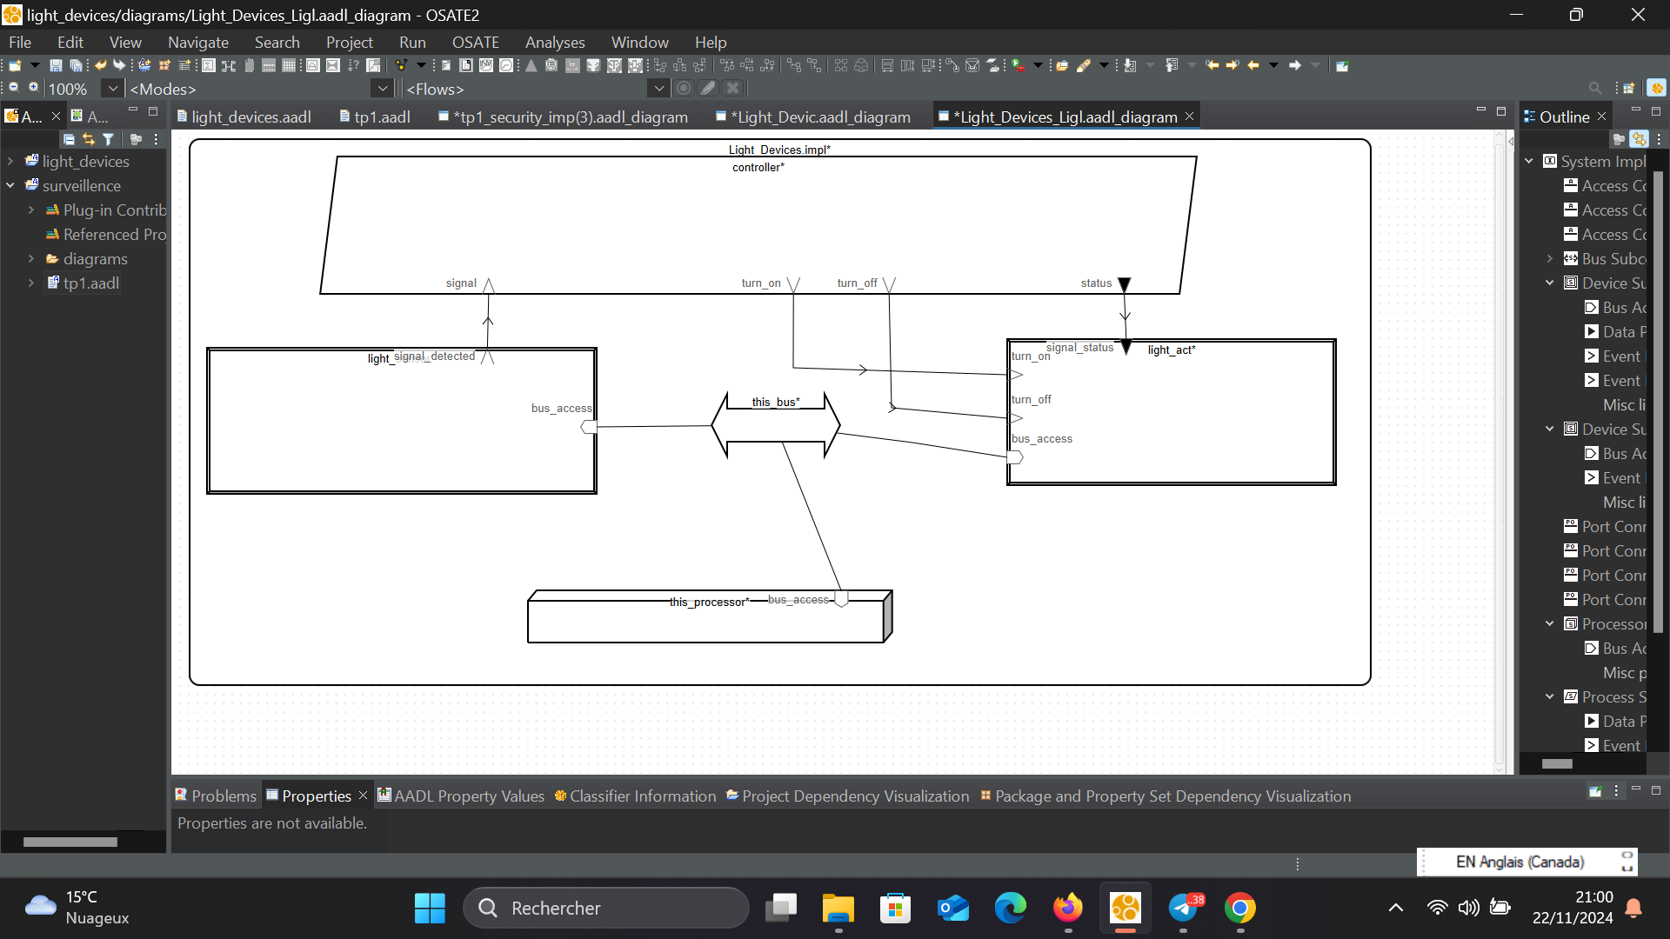

**package** Light_Devices

**public**

**system** Light_Devices

**end** Light_Devices;

**system** **implementation** Light_Devices.impl

**subcomponents**

light_sensor: **device** light_sensor.impl;

controller: **process** controller.impl;

light_act: **device** light_act.impl;

this_bus: **bus** communication_bus.impl;

this_processor: **processor** processing_unit.impl;

**connections**

sensor_to_controller: **port** light_sensor.signal_detected -> controller.signal;

controller_to_actuator: **port** controller.status -> light_act.signal_status;

controller_to_actuators: **port** controller.turn_on -> light_act.turn_on;

controller_to_actuatore: **port** controller.turn_off -> light_act.turn_off;

sensor_to_bus: **bus** **access** light_sensor.bus_access <-> this_bus;

actuator_to_bus: **bus** **access** light_act.bus_access <-> this_bus;

processor_to_bus: **bus** **access** this_processor.bus_access <-> this_bus;

**end** Light_Devices.impl;

**device** light_sensor

**features**

signal_detected: **out** **event** **port**;

bus_access: **requires** **bus** **access** communication_bus.impl;

**end** light_sensor;

**device** **implementation** light_sensor.impl

**end** light_sensor.impl;

**process** controller

**features**

signal: **in** **event** **port**; -- Réception du signal du capteur

turn_on: **out** **event** **port**; -- Commande d'allumage

turn_off: **out** **event** **port**; -- Commande d'extinction

status: **out** **data** **port**; -- État du contrôleur

**end** controller;

**process** **implementation** controller.impl

**end** controller.impl;

**device** light_act

**features**

signal_status: **in** **data** **port**;

turn_on: **in** **event** **port**;

turn_off: **in** **event** **port**;

bus_access: **requires** **bus** **access** communication_bus.impl;

**end** light_act;

**device** **implementation** light_act.impl

**end** light_act.impl;

**bus** communication_bus

**end** communication_bus;

**bus** **implementation** communication_bus.impl

**end** communication_bus.impl;

-- Définition du processeur

**processor** processing_unit

**features**

bus_access: **requires** **bus** **access** communication_bus.impl;

**end** processing_unit;

**processor** **implementation** processing_unit.impl

**end** processing_unit.impl;

**end** Light_Devices;

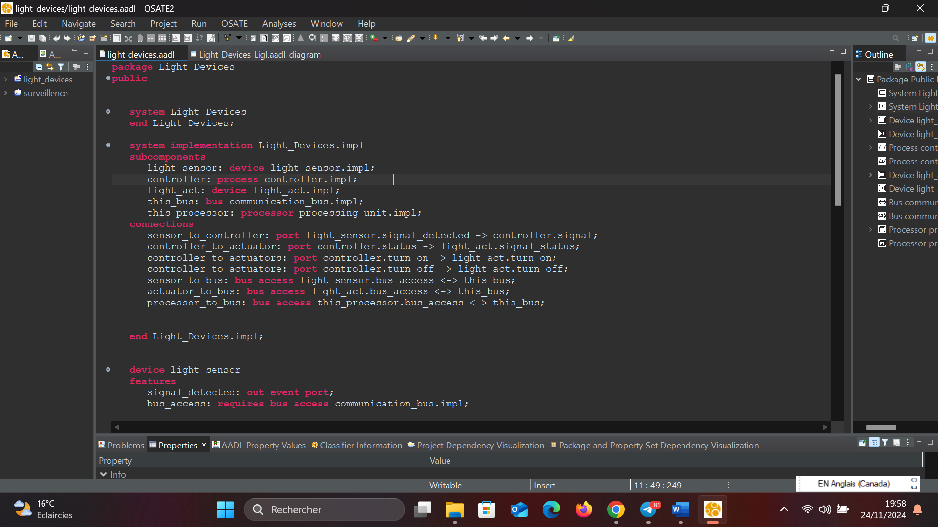

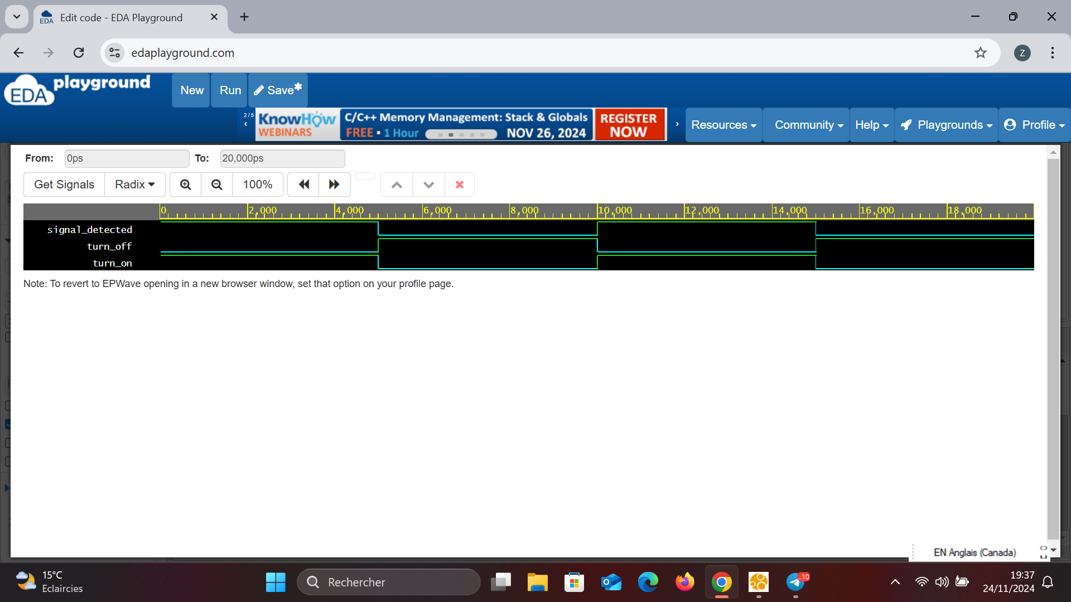

// Code your testbench here.

// Uncomment the next line for SystemC modules.

// #include <systemc>

#include <systemc.h>

#include <fstream>

// Module pour le capteur

SC_MODULE(LightSensor) {

sc_out<bool> signal_detected;

SC_CTOR(LightSensor) {

SC_THREAD(generate_signal);

}

void generate_signal() {

while (true) {

signal_detected.write(true); // Signal détecté

wait(5, SC_NS); // Attendre 5 ns

signal_detected.write(false); // Aucun signal

wait(5, SC_NS); // Attendre 5 ns

}

}

};

// Module pour le contrôleur

SC_MODULE(Controller) {

sc_in<bool> signal;

sc_out<bool> turn_on, turn_off;

SC_CTOR(Controller) {

SC_METHOD(process_signal);

sensitive << signal;

}

void process_signal() {

if (signal.read()) {

turn_on.write(true); // Allumer

turn_off.write(false);

} else {

turn_on.write(false);

turn_off.write(true); // Éteindre

}

}

};

// Module pour l'actionneur

SC_MODULE(LightActuator) {

sc_in<bool> turn_on, turn_off;

SC_CTOR(LightActuator) {

SC_METHOD(control_light);

sensitive << turn_on << turn_off;

}

void control_light() {

if (turn_on.read()) {

std::cout << sc_time_stamp() << " Light Actuator: ON\n";

}

if (turn_off.read()) {

std::cout << sc_time_stamp() << " Light Actuator: OFF\n";

}

}

};

// Fonction pour générer le fichier Graphviz

void generate_graph() {

std::ofstream file("system_graph.dot");

file << "digraph SystemCGraph {\n";

file << " rankdir=LR;\n"; // Orientation de gauche à droite

// Déclaration des noeuds

file << " light_sensor [label=\"Light Sensor\" shape=box];\n";

file << " controller [label=\"Controller\" shape=ellipse];\n";

file << " light_actuator [label=\"Light Actuator\" shape=box];\n";

// Connexions entre les noeuds

file << " light_sensor -> controller [label=\"signal_detected\"];\n";

file << " controller -> light_actuator [label=\"turn_on\"];\n";

file << " controller -> light_actuator [label=\"turn_off\"];\n";

file << "}\n";

file.close();

}

// Fonction principale

int sc_main(int argc, char* argv[]) {

// Générer le fichier Graphviz

generate_graph();

// Signaux

sc_signal<bool> signal_detected_signal, turn_on_signal, turn_off_signal;

// Instanciation des modules

LightSensor sensor("LightSensor");

Controller controller("Controller");

LightActuator actuator("LightActuator");

// Connexions

sensor.signal_detected(signal_detected_signal);

controller.signal(signal_detected_signal);

controller.turn_on(turn_on_signal);

controller.turn_off(turn_off_signal);

actuator.turn_on(turn_on_signal);

actuator.turn_off(turn_off_signal);

// Fichier VCD pour visualiser les signaux

sc_trace_file *trace_file = sc_create_vcd_trace_file("dump");

sc_trace(trace_file, signal_detected_signal, "signal_detected");

sc_trace(trace_file, turn_on_signal, "turn_on");

sc_trace(trace_file, turn_off_signal, "turn_off");

// Lancement de la simulation

sc_start(20, SC_NS); // Simulation pour 20 nanosecondes

sc_close_vcd_trace_file(trace_file);

return 0;

}

